# uA9f5KtUENjWcw9M7feDpbJibY3FWssp0IXx5E-wBmcpPUx_poWOQuM7BK9NW_RKxs1-rKmcW9Ub4zdRPDaNE4UkPvxJfi6RJ2peUdDdOPsDJ6KAuR_PqFVpJl6KK9Xihs-mh_w

# BACHELOR OF COMPUTER APPLICATIONS

**BATCH: 2020-2023**



Summer Training Project Report

# Redistribution of Networking

# 

**Submitted To:-**

Mr. Shivansh

**Submitted By:-**

Jayant

2020397

**Department of computer application**

### Chandigarh Group of Colleges, Jhanjeri, Mohali

**Index**

**1.Introduction**

1.1 Overview

1.2 Background study

1.3 Project Planning

1.4 Purpose

**2.System Design**

2.1 Design

2.2 Feasibility Analysis

2.3 System Analysis

2.4 Technical Feasibility

2.5 Economical Feasibility

**3.Hardware and Software Requirements**

3.1 Hardware Requirements

3.2 Software Requirements

**4.Implementing tool for the project**

4.1 Tools

4.2 Images

**5.Software Testing**

5.1 Why software Testing is need

5.2 Testing Strategy

5.3 White Box

5.4 Blackbox

**6.Conclusion and future enhancement**

6.1 Conclusion

6.2 Future enhancement of project

1.**Introduction**

# Overview

# Redistribution in networking is the importing and exporting of network routes from one routing protocol (or static routing) to another routing protocol. Routers that run two or more routing protocols can be configured for redistribution. An example is a router that runs OSPF and EIGRP, you can import the network routes from OSPF into EIGRP and vice versa. Since routing protocols use different metrics, you will have to manually assign a metric to redistributed routes.

# 

# Project Planning

Project planning is part of project management, which relates to the use of schedules such as Gantt charts to plan and subsequently report progress within the project environment. Initially, the project scope is defined and the appropriate methods for completing the project are determined. Following this step, the durations for the various tasks necessary to complete the work are listed and grouped into a work breakdown structure. The logical dependencies between tasks are defined using an activity network diagram that enables identification of the critical path. Float or slack time in the schedule can be calculated using project management software. Then the necessary resources can be estimated and costs for each activity can be allocated to each resource, giving the total project cost. At this stage, the project plan may be optimized to achieve the appropriate balance between resource usage and project duration to comply with the project objectives. Once established and agreed, the plan becomes what is known as the baseline. Progress will be measured against the baseline throughout the life of the project

# Purposes

The project is about to handle all the information of the shop regarding members. Also it manages resources which were managed and handled by manpower previously. The main purpose of the project is to integrate distinct sections of the shop into consistent manner so that complex functions can be handled smoothly. The project aims at the following matters

* + 1. Easily available Network
    2. Connect multiple devices in single network
    3. Manipulation on different systems at single system.
    4. For saving the time

**System Design**

# Design

The system is divided into several parts like routers, switches, straight cable, serial cable Pc’s and so on.

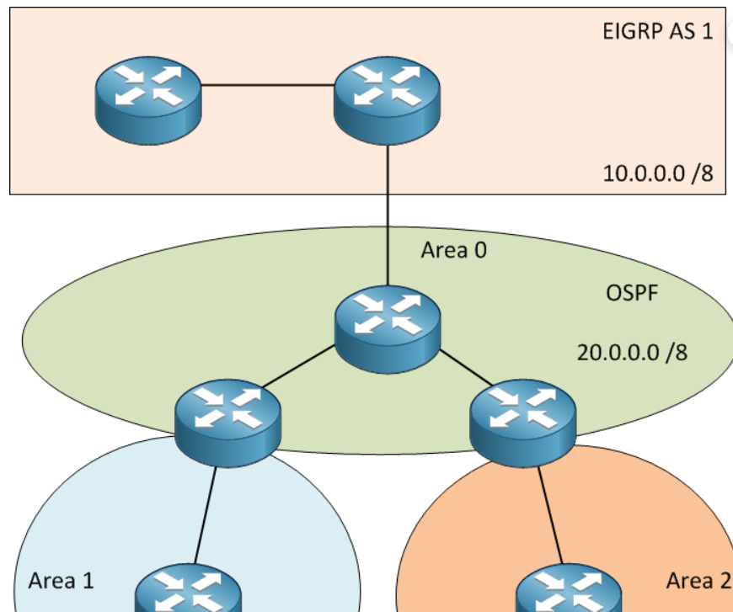

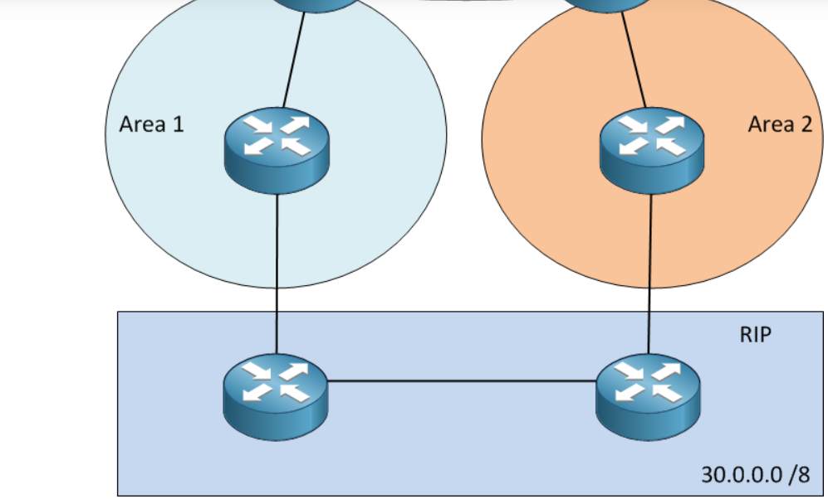

### System Analysis

System Analysis refers into the process of examining a situation with the intent of improving it through better procedures and methods. System Analysis is the process of planning a new system to either replace or complement an existing system. But before any planning is done the old system must be thoroughly understood and the requirements determined. System analysis is therefore, the process of gathering and interpreting facts, diagnosing problems and using the information to re- comment improvements in the system. System analysis is conducted with the following objectives in mind:

* Evaluate the system concept for feasibility.
* Perform economic and technical analysis.
* Allocate functions to hardware, software people, database and other system elements.
* Establish cost and schedule constraints.
* Create a system definition that forms the foundation for all the subsequent engineering work.

# Feasibility Analysis

Whatever we think need not be feasible .It is wise to think about the feasibility of any problem we undertake. Feasibility is the study of impact, which happens in the organization by the development of a system. The impact can be either positive or negative. When the positives nominate the negatives, then the system is considered feasible. Here the feasibility study can be performed in two ways such as technical feasibility and Economical Feasibility.

#### **2.4 Technical Feasibility**

#### It is technically feasible, since there will not be much difficulty in getting required resources for the development and maintaining the system as well. All the resources needed for the development of the software as well as the

#### **2.5 Economical Feasibility**

Development of this application is highly economically feasible.The organization needed not spend much m one for the development of the system already available. The only thing is to be done is making an environment for the development with an effective supervision. If we are doing so, we can attain the maximum usability of the corresponding resources .Even after the development , the organization will not be in a condition to invest more in the organization .Therefore , the system is economically feasible.

Maintenance.

**3.Hardware and Software Requirement**

# Hardware Required

* + 1. **Processor :** i3 or Above
    2. **Hard Disk :** 1GB or above
    3. **Ram :**512 MB
    4. **Input Devices :** Keyboard, Mouse
    5. **Output Devices:** Monitor

# Software Required

* **Operating System:** Linux, Windows, Mac
* **Backend :** Networking Protocols

**4.Implementing Tools for the Project**

# Tools

Cisco Packet Tracer✓

* 1. **Image**

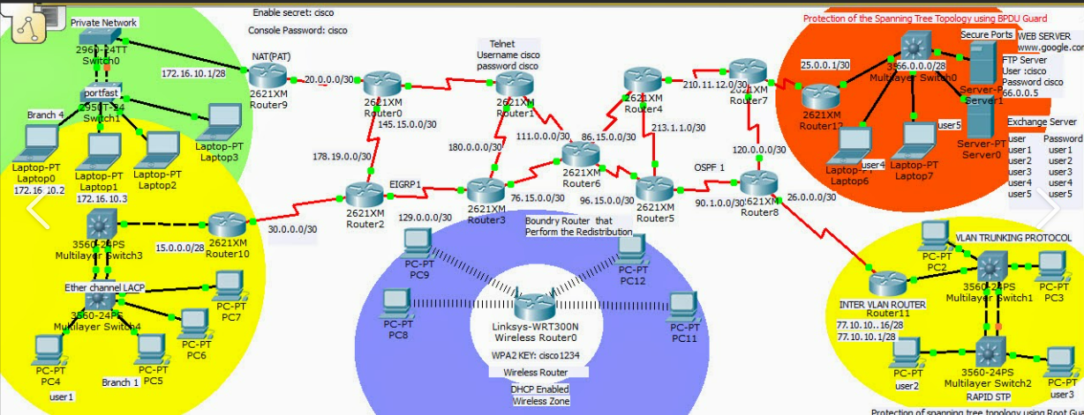

**5. Software Testing**

### Why Software Testing is Needed

Tool-bars work properly? Are all menu function and pull down sub function properly listed? Is it possible to invoke each menu function using a logical assumptions that if all parts of the system are correct, the goal will be successfully achieved? In adequate testing or non-testing will leads to errors that may appear few months later. Testing represents an interesting anomaly for the software engineer. During earlier software engineering activities, the engineer attempts to build software from an abstract concept to a tangible product. Now comes testing. The engineer creates a series of test cases that are intended to “demolish” the software that has been built. In fact, testing is the one step in the software process that could be viewed (psychologically, at least) as destructive rather than constructive. Testing requires that the developer discard preconceived notions of the “correctness” of software just developed and overcome a conflict of interest that occurs when errors are uncovered.

If testing is conducted successfully (according to the objectives stated previously) it will uncover errors in the software. As a secondary benefit, testing demonstrates that software functions appear to be working according to specification, that behavioral and performance requirements appear to have been met. In addition, data collected as testing is conducted provide a good indication of software reliability and some indication of software quality as a whole. But testing cannot show the absence of errors and defects, it can show only that software errors and defects are present. It is important to keep this (rather gloomy) statement in mind as testing is being conducted.

### Testing Strategy

There are types of testing that we implement. They are as follows:

While deciding on the focus of testing activities, study project priorities. For example, for an on- line system, pay more attention to response time. Spend more time on the features used frequently. Decide on the effort required for testing based on the usage of the system. If the system is to be used by a large number of users, evaluate the impact on users due to a system failure before deciding on the effort.

This create two problem

* Time delay between the cause and appearance of the problem.
* The effect of the system errors on files and records within the system.

The purpose of the system testing is to consider all the likely variations to which it will be suggested and push the systems to limits. The testing process focuses on the logical intervals of the software ensuring that all statements have been tested and on functional interval is conducting tests to

uncover errors and ensure that defined input will produce actual results that agree with the required results. Program level testing, modules level testing integrated and carried out.

There are two major type of testing they are:

* White Box Testing.
* Black Box Testing.

# White Box Testing

White box sometimes called “Glass box testing” is a test case design uses the control structure of the procedural design to drive test case. Using white box testing methods, the following tests where made on the system

* + 1. All independent paths within a module have been exercised once. In our system, ensuring that case was selected and executed checked all case structures. The bugs that were prevailing in some part of the code where fixed
    2. All logical decisions were checked for the truth and falsity of the values.

# Black Box Testing

Black box testing focuses on the functional requirements of the software. This is black box testing enables the software engineering to derive a set of input conditions that will fully exercise all functional requirements for a program. Black box testing is not an alternative to white box testing rather it is complementary approach that is likely to uncover a different class of errors that white box methods like.

* Interface errors.
* Performance in data structure.
* Performance errors.

Initializing and termination errors.

**6.Conclusion & Future Enhancement**

**6.1 Conclusion**

This project is useful in networking field. After using this project, systems are arrange in a order. It is a blueprint of the routing protocols. There are various protocols are used in this project like router rip, OSPF and EIGRP. This project is helps in various computer labs and networking purposes.

**6.2 The following are the future scope for the project.**

1.Systems are designed or arrange in order

2.Different Systems are connected to single or multiple systems

2.Easy to Share Data and time saving Process